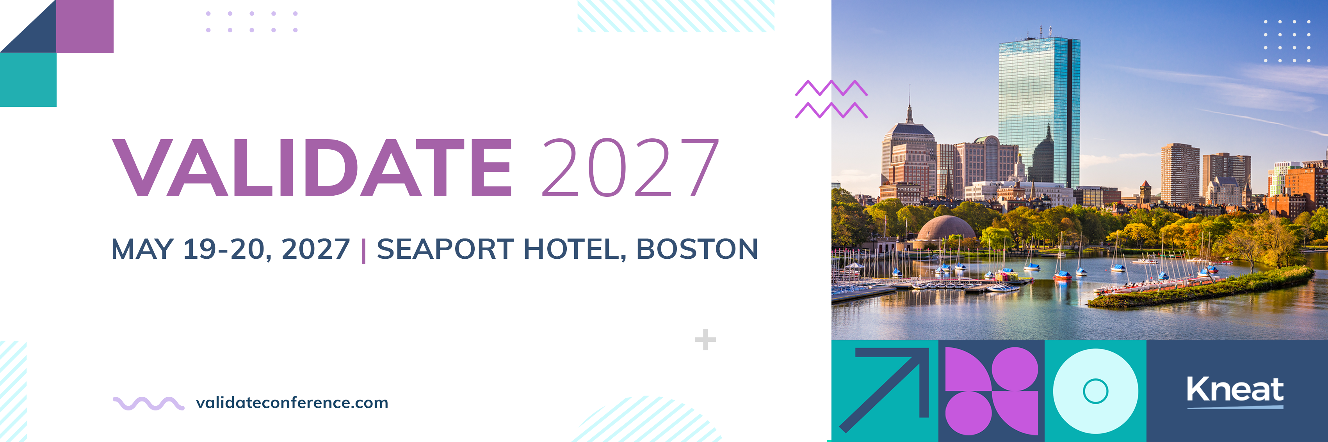
[Date]
Dear [Manager],
I would like your approval to attend this two-day, multi-track, intensive educational and training conference specifically designed for validation and quality professionals working in highly regulated industries.
About VALIDATE 2027
VALIDATE 2027 brings together senior Quality Executives, Validation Engineers, Specialists, and Managers, QA and Validation Technologists, and Regulatory Experts with Life Sciences industry influential leaders to connect, collaborate, discover and apply validation trends, technologies, regulations, and best practices.
The conference is the premier event for tech-forward validation and quality professionals. The conference schedule features many expert speakers, including industry leaders in Pharma, Biotech, Medical Device, Consumer Health, CMOs and more. Past customer speakers include Biogen, Eli Lilly & Co, GSK, Merck & Co., Sanofi, Thermo Fisher, Alcon, and more.
Customer-Exclusive Benefits
- Private customer networking reception before the conference begins
- Exclusive sessions: product vision, roadmap, and training on new Kneat Gx functionality
- Direct access to Kneat experts and peers driving digital validation globally
- Access to a VIP meeting space to take calls and catch up
- Full post event recordings, including customer only sessions
Conference Highlights
- Solving real validation challenges facing your team right now
- Data integrity as the foundation for responsible AI
- Unlocking intelligence from validated data — without losing compliance or control
- Closing the digital maturity gap across your organization
- Integration with your key systems
- Expanding the value of your investment
Attending VALIDATE will help me:
- Gain actionable insights to optimize our validation processes
- Learn new Kneat Gx features and time-saving strategies
- Build peer connections to exchange best practices
- Enhance productivity and alignment between our validation goals and business outcomes
The event is organized by Kneat — they understand the role, the challenges, and the skills required to be a successful validation professional, and I believe that the content at the conference will positively support my role, provide me with the latest technological tools, knowledge, and connections that will help me to achieve more efficiencies for our organization.
Here are the details:
- Event Name: VALIDATE 2027
- Date: May 19-20, 2027
- Location: Seaport Hotel, Boston, MA USA
- Registration fee: $499 through January 31, $599 through April 15, and $699 through May 18. Please contact your CSM for customer only discount code

Best regards,
[NAME, TITLE]

