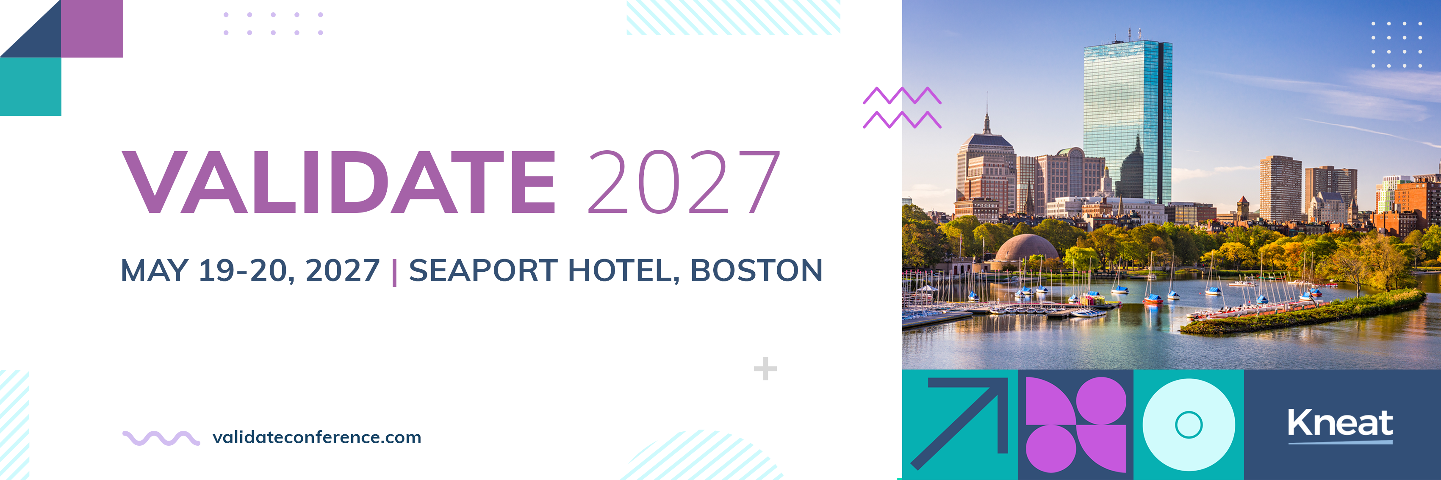

[Date]
Dear [Manager],
I would like your approval to attend this two-day, multi-track, intensive educational and training conference specifically designed for validation and quality professionals working in highly regulated industries.
VALIDATE 2027
VALIDATE 2027 brings together senior Quality Executives, Validation Engineers, Specialists, and Managers, QA and Validation Technologists, and Regulatory Experts with Life Sciences industry influential leaders to connect, collaborate, discover and apply validation trends, technologies, regulations, and best practices.
The conference is the premier event for tech-forward validation and quality professionals. The conference schedule features many expert speakers, including industry leaders in Pharma, Biotech, Medical Device, Consumer Health, CMOs and more. Past customer speakers include Biogen, Eli Lilly & Co, GSK, Merck & Co., Sanofi, Thermo Fisher, Alcon, and more.
The agenda includes:
- Multiple expert-led conference sessions with insights into validation, technology, and best practices including topics on:
- Solving real validation challenges facing your team today
- Building trust through data integrity as the foundation for responsible AI
- Unleashing AI's potential to unlock intelligence from validated data
- Realizing efficiency gains while maintaining compliance and control
- Closing the digital maturity gap across your organization
- Mastering data lifecycle management in the era of Validation 4.0
- Accelerating transformation through the Intelligent GxP Enterprise

By attending I will:
- Learn processes and tools that will aid best-practice validation management
- Receive digital validation software training from industry professionals who support life sciences world leaders
- Have increased productivity and time-saving measures
- Gain insights into smarter use of our resources (people, processes, and technologies)
- Have opportunities to establish connections in validation for future advice and best practices
- Learn how to implement effective strategies to align my role and the business needs
- Build industry relationships and network with peers, partners, and vendors facing similar validation challenges through networking opportunities
- Advance professional expertise in high-demand areas like AI governance, digital validation, and GxP practices
- Return with actionable strategies that directly improve our validation processes, timelines, and organizational capability

The event is organized by Kneat — they understand the role, the challenges, and the skills required to be a successful validation professional, and I believe that the content at the conference will positively support my role, provide me with the latest technological tools, knowledge, and connections that will help me to achieve more efficiencies for our organization.
Here are the details:
- Event Name: VALIDATE 2027
- Date: May 19-204, 2027
- Location: Seaport Hotel, Boston, MA USA
- Registration fee: $649 through January 31, $749 through April 15, and $849 through May 18.

Best regards,
[NAME, TITLE]

